Location Assessment and local profile
Westmoreland Road, Bromley
London BR2 0QL

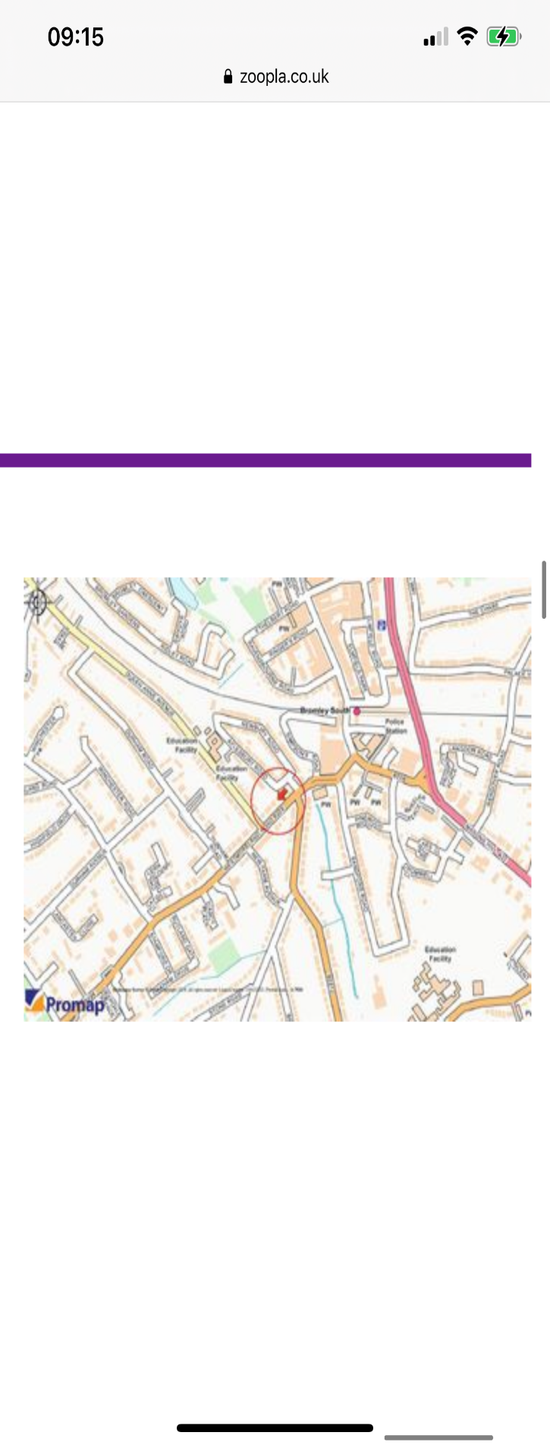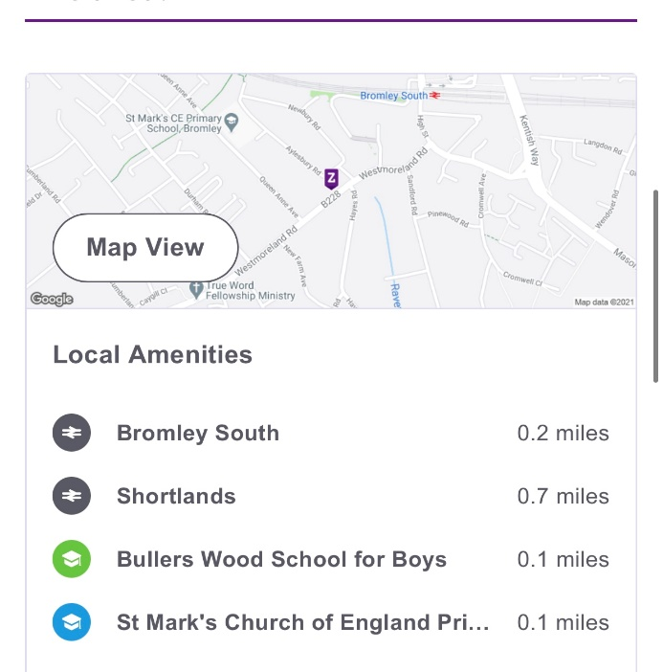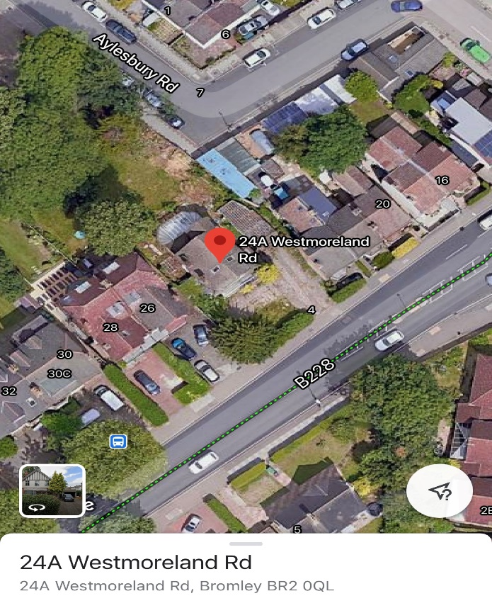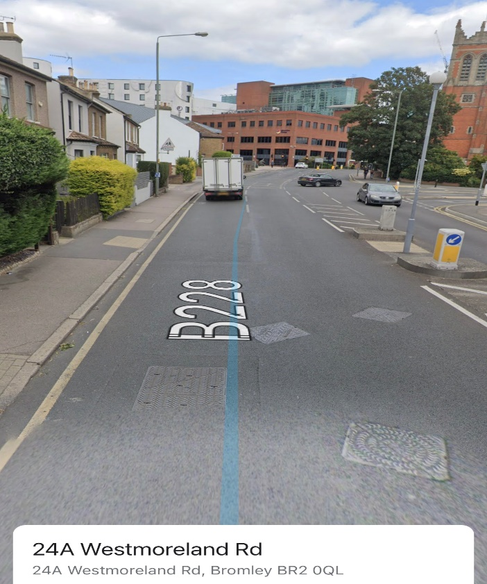

Area profile & accessibility of local services

Westmoreland Road in Bromley is in the London region of England. The postcode is within the Shortlands ward/electoral division, which is in the constituency of Beckenham. The Local Authority of Westmoreland Road is Bromley. The London Borough of Bromley is the south easternmost of the 32 London boroughs that make up Greater London, bordering the county of Kent, which most of Bromley was part of before 1965. The borough's population is presently an estimated 334,536.

Ranked as one of the happiest boroughs in London, Bromley is a pleasant and prosperous area, albeit rather quiet and indistinct. The unemployment rate here is one of the lowest in London, and the good schools, suburban ambience and access to the green expanses of the Kent Downs make it a particularly popular place of choice.
Westmoreland road is located in the quieter conservation area of Bromley, a semi - leafy part of Bromley with pleasant looking homes on the market for an average £550,000 -£1,000,000 price tag.
Across the borough, large Victorian detached properties are mixed with modern apartments, although around Bromley town centre it is more common to see terraced properties lining the streets. Beautiful cottages can be found in Bromley Old Town, but it is perfectly possible to find a modern flat to suit commuter needs in Bromley South, an area which is currently undergoing a £90 million regeneration project.
The area is well served by four bus routes within five minutes’ walk away, and a close main line train station, Bromley South which is 12 minutes’ walk away.
Popular attractions include the theatres, Intu Shopping centre which is a few minutes away and several sports and leisure activities.

POPULATION STATISTICS
Bromley town, including its neighbourhoods and villages, is formed of six wards: Bickley; Bromley Common and Keston, Bromley Town, Hayes and Coney Hall, Plaistow and Sundridge, and Shortlands.
In a recent census, Bromley town was seen to be made up of approximately 52% females and 48% males with the average age of people in Bromley being 40, while the median age is 40.
94.2% of people living in Bromley speak English. The other top languages spoken are 0.5% Polish, 0.4% French, 0.3% Turkish, 0.3% Spanish, 0.3% Portuguese, 0.2% Tamil, 0.2% All other Chinese, 0.2% Italian, 0.2% Russian. In Bromley Town, 18.5% of the population is of minority ethnicity. Residents within the 3-mile radius come from diverse communities. The local area benefits from a healthy mix of cultures and does not consist of a significant one - sided majority of ethnicities.

SAFETY
Bromley is a safe area to live in London and ranked as the 6th safest among the London Boroughs.
Annual crime rate in Bromley postcode area is 25.2, i.e. 25.2 crimes reported per annum per 1000.which is significantly lower than the London average if 93 per 1000. The total number of "violent crime" is 6.6k, and this number has decreased by 2.3% when compared year-over-year in the period of December 2019 - November 2020. Anti-social behaviour was the fastest growing crime in the borough.
The town has a large retail area, including a pedestrianised High Street and the Intu Shopping Centre on Bromley High Street formerly known as The Glades Shopping centre . The centre offers residents and visitors the opportunity to shop, eat and socialise under one roof, with a range of popular high street stores from Karen Millen and Kurt Geiger to H&M, Mac, Gap, Oasis, Russell & Bromley and Waterstone's, so it meets the needs and taste of everyone. There are also a number of restaurants including a branch of the small chain of Belgian-themed Belgo restaurants, and community minded cafes such as Lavender House café, a family friendly independent coffee shop with a popular children’s play area. Development at the nearby St. Mark's Square has seen further restaurants and a cinema established.
The Borough as a whole, has a selection of restaurants which offer a variety of tasty Indian, Thai, British, Japanese and European cuisine. From the up-market Michelin-starred experience of Mediterranean restaurant Chapter One in Orpington, to the heady aromas of Indian restaurant Pink Garlic on Chatterton Road, there is something to suit most tastes and budgets in this south-eastern borough.
Bromley High Street is also the location for the Bromley Charter Market, which runs on a Tuesday, Thursday and Saturday. The Market sells food and confectionery items, clothing and other goods like jewellery.
Large branches of most major supermarket chains can be found in Bromley, including a Tesco Superstore on Holmesdale Road and a large Waitrose on Burnt Ash Lane, as well as small local branches throughout the borough.

SAFEGUARDING CONCERNS

There are no major concerns about the locality in which the home is based. There are low levels of crime, and the area is not highlighted by the local neighbourhood team or the MCSETO group as an area of concern.

There are no concerns of young people being drawn into gang crime or anti-social behaviour in the area as a result of the locality of the home. The home’s location does not increase the potential for children to be targeted for sexual exploitation, there are a number of take-aways and shops locally which research has evidenced have been hot spots for the grooming and exploitation of children, however, the area in which Westmoreland Road is located has not been an area of concern at the local multi-agency CSE, Missing and Trafficking operational group where this information is collated.

Westmoreland Road, Bromley, BR2 0TY is within the Sortland’s policing neighbourhood, under the Metropolitan Police Service force area.
Current areas of identified risk are concerns as to some environmental factors of the home.

The home has a main road in front of it and then some shops within walking distance. Though the shops are located on another main road that is relatively very busy, the speed is strictly limited to 30 MPH and has speed cameras along it. The road does not pose a high risk as the young people are of an age where they can cross the road safely to access local shops.

Although there are waterways and a train station nearby, these are not within the proximity of the home where they would pose a risk to the young people going about their day to day activities.

Another risk area is the close proximity of local take-aways, although there has been no concern over these businesses raised at the multi-agency meeting it is an area of potential risk given current research. Another area of environmental risk is the building works taking place re the regeneration. There is a use of plant machinery however; the site has clear health and safety notices and security on site 24hours a day.

The home is situated in a quiet leafy road of family homes with large extensive
gardens. The street itself has nil to little criminal activity and is quite a pleasant area
with good neighbours near to an educational facility.

The overall risk of the location of the home is assessed as being low risk. And it is in a neighbourhood watch area.
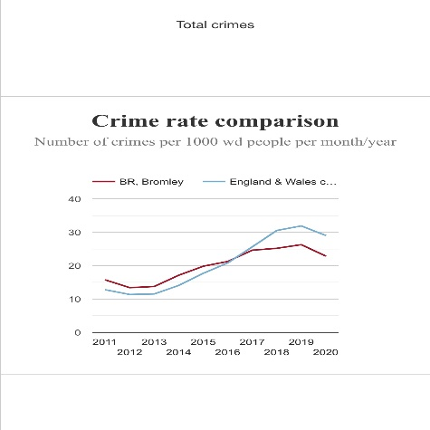

Crime breakdown BR2
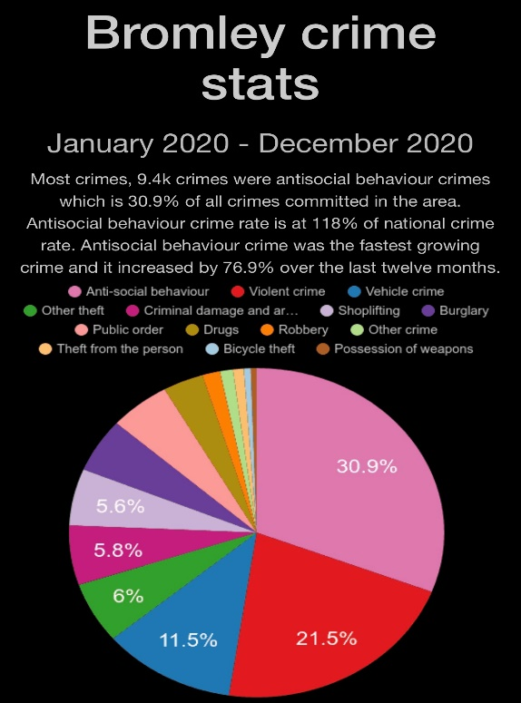

SUPPORT SERVICES FOR YOUTHS
Bromley has local organisations, groups and individuals who offer activities, services and advice to local young people.
The Bromley Youth Support Programme (BYSP) brings together different services for young people. They have on offer the following services:
- Youth centres (Hubs) Castlecombe, The Link and Duke, Spitfire and Streetwise based in specific areas providing activities and support.
- A project for young people with disabilities,
- A mobile team, that visits areas of the borough with music and kitchen bus,
- A Duke of Edinburgh award team that helps them to achieve bronze, silver or gold awards
- Youth involvement team that can help the youth and parents/guardians to have a say about issues affecting them and other young people.
There is also help and support in finding a job, college course or training at their drop in sessions.

TRANSPORT
The nearest railway station by Westmoreland Road in Bromley is Bromley South and this is the town’s main station located on 1.1 km. It is 899 meters away from the property 24A Westmoreland road and this is a 12-minute walk and a 2-minute car ride away. Bromley South is served by South eastern services to London Victoria which also connects the town with Southeastern shuttle services to Grove Park where connections can be made for services to London Charing Cross and London Cannon Street via Lewisham.

In addition to the train, the west of Bromley has a tram system served by Tramlink. This offers services between stations including Biggin Hill, Croydon, and Wimbledon. Moreover, the borough has good road networks, with Gatwick, Heathrow and London City airports all easily accessible. Biggin Hill Airport is also located in the borough itself, although it is only available for business jets and private flying rather than commercial services. For a more environmentally friendly mode of transport, Bromley has over 100 cycle routes with some going as far as Waterlink way in Lewisham.

Bromley is also served by different routes on London Buses with great connections.

SCHOOLS AND EDUCATION
Bromley is well known for its good schools, many of which have achieved Ofsted Outstanding status. Families are therefore frequently drawn here. The best primary schools in Bromley include St Joseph’s Catholic Primary School, St James RC School and Farnborough Primary School, while for secondary students Buller Wood School in Chislehurst and Highfield Junior School in Shortlands are among the best schools in Bromley.
Among the independent schools, Bromley High School and Eltham College are both particularly sought -after, while for further education the borough is home to London South East College, Nash College of Further Education and Bromley Adult Education College.
Bromley also has two specialist Media Arts Schools, and a specialist music college.

In addition to the above, Bromley has several special schools such as The Glebe school a special school that caters for students aged 11-19 with special needs, Majorie McClure School that caters for pupils with a wide range of complex needs, Bickley primary school , Alexandra Infant school, Autism special school, and a range of other specialists on how children and young people develop and learn. They offer assessment, advice and support to parents and teachers where there is a concern about the development, learning or behaviour of children and young people

SPORTS AND LEISURE

Bromley has a selection of gyms and fitness suites, ranging from well-known clubs such as Trugym, Nuffield Health and Virgin Active to council-run services including the Pavilion Leisure Centre and Darwin Sports Centre

Alternative outdoor activities are in good supply, with a number of tennis clubs, non-league football clubs, rugby clubs, golf courses and cricket clubs dotted around the borough. For something less structured, a weekend walk of the Kent Downs is highly recommended.

CULTURE
There are tons of things to see and do in Bromley. One of Bromley’s most popular attractions is The Churchill Theatre, which not only offers weekly youth theatre classes for children aged 4-21 but also hosts a range of dramatic performances, while for history fans the remains of Roman estate can be found in Crofton.
There is also the Bromley Little Theatre close to Bromley North railway station. Bromley also has a central library in the same building as the Churchill Theatre with a large book stock, Internet and wifi access, reference library and local studies department. It functions as the central library of the broader Bromley Borough Libraries Service. In addition cinemas in Bromley consist of the Picture house which was opened in June 2019 in the previous Empire theatre, and the Vue Cinemas , a nine-screen cinema, which is part of the Bromley South Central scheme at St Mark's Square, opened on 28 November 2018.

GREEN SPACE
Lastly, if you are looking to relax, Bromley is one of the few boroughs in London blessed with scenic views of the countryside. On the southern border, the tumbling expanse of the Kent Downs is the perfect place for locals to enjoy spectacular views, rolling hills and open grassland.
Other green spaces in the borough include High Elms Country Park in Orpington, which has site of special scientific interest status and boasts 250 acres of woodland and meadows, a nature reserve and a 150-acre golf course.

BELOW IS THE LINK FOR BROMLEY DEMOGRAPHY.

https://directory.londoncouncils.gov.uk/demographics/bromley/

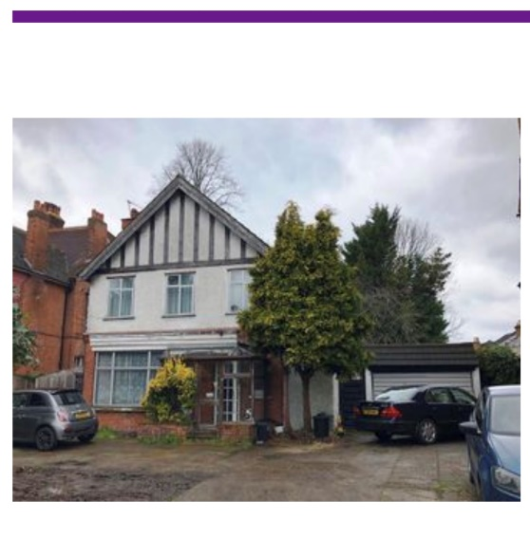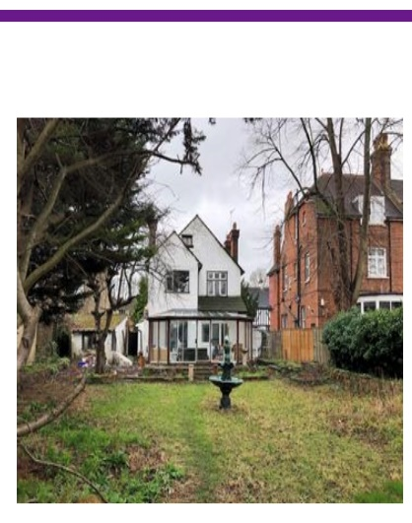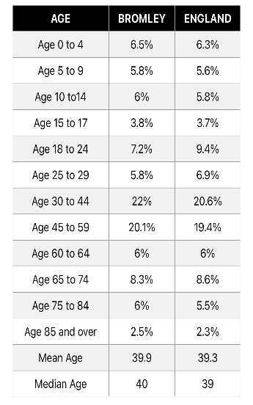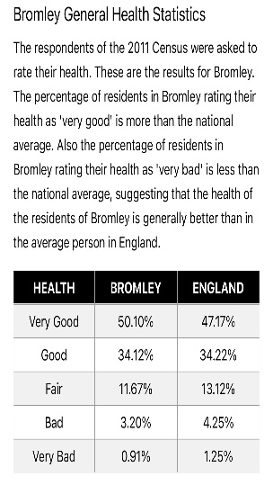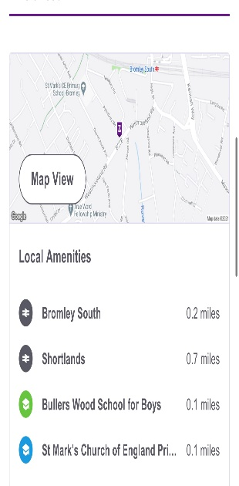
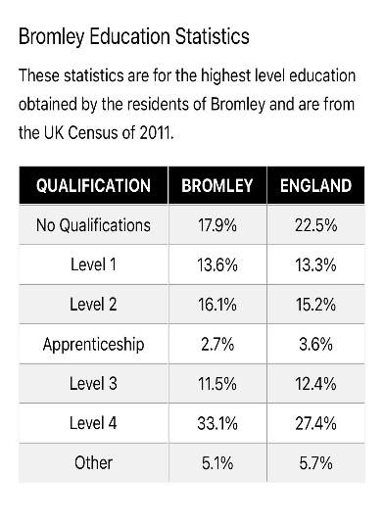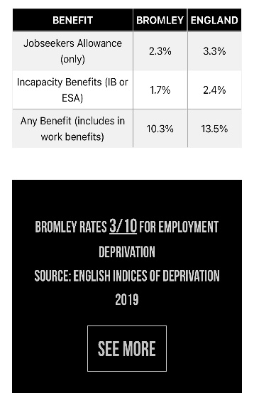

Metropolitan crime statistics to see how past years’crime figures compare within nearby boroughs Number of crimes per borough 2014-2018

Borough | 2014/2015 | 2015/2016 | 2016/2017 | 2017/2018 | 2018/2019 | 2019/2020
Barking and Dagenham | 17,939 | 19,343 | 19,445 | 20,160 | 20,862 | 21,189
Barnet | 25,328 | 27,737 | 28,398 | 29,807 | 32,403 | 31,911
Bexley | 13,343 | 13,751 | 15,184 | 16,440 | 18,192 | 18,323
Brent | 27,242 | 29,023 | 30,699 | 33,168 | 33,493 | 31,725
Bromley | 22,521 | 22,644 | 23,755 | 24,725 | 25,848 | 25,802
Camden | 31,900 | 32,211 | 35,875 | 41,218 | 40,434 | 38,530
Croydon | 32,148 | 31,731 | 33,284 | 33,251 | 34,422 | 36,790
Ealing | 28,831 | 29,874 | 30,807 | 30,562 | 32,560 | 32,841
Enfield | 24,146 | 25,193 | 25,895 | 28,816 | 31,556 | 32,080
Greenwich | 23,068 | 24,260 | 26,855 | 27,329 | 29,550 | 30,019

2019/2020 Crime rates statistics for the above boroughs stand at

Barking and Dagenham 21,189
Barnet 31,911
Bexley 18,323
Brent 31,725
Bromley 25,802 still showing as one of the lowest and safest boroughs in London
Camden 38,530
Croydon 36,790
Ealing 32,841
Enfield 32,080
Greenwich 30,019

